Applied Machine Learning

LAB Project



Comparative Analysis of Machine Learning

Models for Human Activity Recognition (HAR)

Submitted by:

Hussnain Shams Ul Qamar | 22L-6246
Muhammad Shayan Shahbaz | 22L-7683

Submitted to:
Eman Dar

07/12/2025

Department of Electrical Engineering
National University of Computer and Emerging Sciences, Lahore

Introduction
- Problem Analysis

Design Requirements
- Feasibility Analysis

Possible Solutions
- Preliminary Design

Design Description

Software Simulation

Experimental Results
- Performance Analysis
- Future Scope

Social and Cultural Implications
- Conclusion References
In the modern landscape of digital health and smart technology, the ability to automatically monitor and interpret human behavior is becoming a cornerstone of innovation. This project focuses on the design, implementation, and rigorous analysis of a machine learning pipeline specifically engineered for Human Activity Recognition (HAR).

The primary objective was to accurately classify six distinct physical activities
- Walking,
- Walking Upstairs,
- Walking Downstairs,
- Sitting,
- Standing and
- Laying
by analyzing complex data gathered from smartphone inertial sensors (accelerometers and gyroscopes). This research has profound real-world implications; as wearable technology becomes standard in elderly care and patient monitoring, the computational ability to distinguish between a static posture (like sitting) and a dynamic movement (like falling) becomes a critical safety feature.
This project covers the entire data science lifecycle, starting with a meticulous exploratory analysis of a dataset comprising 10,299 instances and 35 distinct features. We progressed from raw data preprocessing to the deployment of advanced ensemble classifiers. By testing a spectrum of models—from basic linear equations to complex Random Forests—this project aims to identify an architecture that balances high prediction accuracy with the efficiency required for mobile devices.
The core challenge in this project is multi-class classification within a high-dimensional feature space. While humans can visually distinguish between walking and sitting easily, translating these actions into mathematical patterns is difficult due to three main factors:
- Non-Linearity: The decision boundaries separating dynamic activities (like walking upstairs vs. downstairs) are mathematically complex. These activities share similar signal characteristics, making them difficult to separate using simple straight lines.
- Multicollinearity: Our analysis revealed high correlation among the 35 sensor features. For example, accelerometer readings on the X-axis often mirror the Y-axis during coordinated movement, leading to redundancy.
- Risk of Overfitting: This redundancy creates a risk where the model "memorizes" background noise rather than learning actual movement patterns.
To solve this, we determined that simple classification was insufficient. The solution required Regularization (Lasso/Ridge) to penalize complexity, Dimensionality Reduction (PCA/LDA) to distill the data, and robust Non-Linear Classifiers (Random Forest) to ensure generalization.
Support Vector Machines, to ensure the model could generalize well to new, unseen user data.

The system design was governed by a set of strict engineering requirements regarding input processing, model evaluation, and output validity to ensure the scientific rigor of the results. These requirements acted as the blueprint for the entire pipeline.
- Input Specifications: The system was designed to accept a feature vector consisting of 35 standardized numerical values derived from raw sensor readings. These inputs are not raw voltages but processed signal features, including means and standard deviations of acceleration.
- Preprocessing Constraints: A non-negotiable requirement for the preprocessing stage was Feature Scaling. To ensure algorithm stability—particularly for distance-based models like K-Nearest Neighbors and Support Vector Machines that calculate Euclidean distances between points—it was required to scale all features using a Standard Scaler to achieve zero mean and unit variance. Without this, a feature with a large range would disproportionately influence the model, leading to biased predictions.
- Output Specifications: The output requirement was to produce encoded target labels, discrete integers ranging from zero to five, facilitating standard multi-class classification metrics. Ideally, the system should also provide probability estimates for these classes to allow for thresholding.
- Validation Requirements: The critical design requirement was the implementation of K-Fold Cross-Validation, specifically with five splits. This technique divides the dataset into five distinct subsets, ensuring that every single data point is used for both training and validation phases at some point in the cycle. This requirement was set to prevent the bias that can occur with a simple train-test split and to provide statistically reliable estimates of model performance metrics, including Accuracy, Precision, Recall, Mean Squared Error, and R-squared.

The feasibility of the project was analyzed across computational, software, and time dimensions to ensure that the ambitious goals could be met within the constraints of the academic term. The analysis confirmed that while the logic was complex, the tools available made the project achievable.
- Computational Feasibility: The project leveraged the extensive and mature Python ecosystem, specifically utilizing highly optimized libraries like scikit-learn and TensorFlow ⁹. These libraries are critical for feasibility because they implement complex mathematical algorithms in low-level, high-performance languages such as C and C++. This allowed computationally intensive models like the Random Forest, which constructs 100 separate decision trees, and the Support Vector Machine, which calculates high-dimensional hyperplanes, to train on over ten thousand data rows in mere seconds on standard consumer hardware.
- Time Management: Time management was another crucial feasibility factor. The project was deemed feasible within the allotted time due to the modular design of the pipeline, which allowed for rapid prototyping and testing of different algorithms without rewriting the core data handling code.
- Algorithm Constraints: We did encounter a significant computational constraint with specific visualization algorithms. The t-SNE (t-Distributed Stochastic Neighbor Embedding) algorithm, while excellent for visualization, has a time complexity that grows quadratically with the data size. Attempting to run this on the full dataset caused significant delays. To maintain feasibility for the visualization task without crashing the system or waiting hours for a single plot, a strategic sampling constraint was introduced. By limiting the input to 1500 randomly selected instances for this specific task, the system ensured that the 3D visualization could be generated in real-time during the analysis phase without stalling the execution environment.

To determine the optimal classification strategy, we did not simply pick one method; we evaluated a broad spectrum of machine learning paradigms to find the best fit for the specific characteristics of HAR data. We broke the potential solutions down into four distinct categories:
- Linear Models: We initially implemented Logistic Regression and Linear Regression as baseline solutions. These models are computationally cheap and highly interpretable, providing a good reference point. However, we hypothesized that they would fail to capture the complex non-linear relationships inherent in sensor data, serving primarily to prove the difficulty of the task.
- Ensemble Methods: Following the baselines, we explored Ensemble Methods, specifically Random Forests. This approach aggregates predictions from multiple decision trees. We considered this a strong candidate because Random Forests inherently handle non-linear data and create robust decision boundaries by averaging out the errors of individual trees, making them resistant to overfitting.
- Dimensionality Reduction: We also investigated Dimensionality Reduction solutions, comparing Unsupervised PCA against Supervised LDA. While PCA is the standard for reducing noise, we explored LDA as a potentially better solution for classification tasks because it explicitly attempts to separate class clusters based on labels, rather than just preserving variance.
- Deep Learning: Finally, Deep Learning models like CNNs and MLPs were considered. Theoretically, 1D-Convolutional Neural Networks are the ideal solution for time-series data as they can learn temporal patterns and sequential dependencies that static models miss . However, they require significant data volume and hyperparameter tuning.
After a careful comparison of these potential solutions against our design requirements, the Random Forest Classifier was ultimately selected as the primary solution. It offered the best balance, delivering superior accuracy compared to linear models and offering unique interpretability through feature importance rankings.

The preliminary design established a modular Machine Learning Pipeline to ensure consistency, reproducibility, and scalability across all experiments. This was not a linear script but a structured workflow designed to process data in distinct stages.
- Data Ingestion: The process begins with Data Ingestion, which involves reading the raw CSV files containing the sensor feature streams and verifying data integrity to ensure no corruption occurred during file transfer.
- Preprocessing Module: This step handles the essential cleaning tasks. It applies Label Encoding to convert text labels (like "Walking") into machine-readable integers, and applies Standard Scaling to the feature set ($X$) to normalize the data distribution ¹²¹²¹²¹².
- Iterative Validation Loop: The core of the design is the Iterative Validation Loop. Instead of a single pass, the processed data is fed into a K-Fold Cross-Validation system ¹³. This loop effectively instantiates a new version of the model for each fold to ensure robustness.
- Model Training & Evaluation: Inside the loop, the specific model architecture—whether it be a Random Forest, SVM, or Neural Network—is trained on the fold's training set and evaluated on the validation set.
- Metrics Aggregation Module: Finally, this module collects the raw performance data, such as Accuracy, Precision, and Recall scores, from all five folds. It calculates the mean performance and standard deviation to provide a holistic view of how the model performs.
This structured approach allows for the "plug-and-play" testing of different algorithms. We could swap a Linear Regression model for a Random Forest model without altering the underlying data processing or evaluation logic.

The final design incorporates three specialized components to address the specific data challenges encountered during the analysis phases. These components work in tandem to optimize accuracy, efficiency, and interpretability.
- Classification Engine (Random Forest): The primary engine utilizes a Random Forest model. This is an ensemble of 100 distinct decision trees. It operates on the principle of "wisdom of crowds," reducing the variance associated with individual trees by using a technique called bootstrap aggregating (bagging). Each tree votes on the class, and the majority wins. The model evaluates split quality at each node using mathematical criteria like Gini Impurity, allowing it to construct complex, non-linear decision boundaries that linear models simply cannot achieve.
- Complexity Management (Lasso): To handle the high feature redundancy identified earlier, the system integrates a Complexity Management component using Lasso Regression. Lasso utilizes L1 regularization, which adds a penalty equal to the absolute value of the magnitude of coefficients. This unique mathematical property forces the coefficients of less important features to become exactly zero. This effectively performs automatic feature selection, identifying the 7 most critical sensors out of the original 34 and discarding the rest.
- Visualization and Reduction (LDA): For Visualization and Reduction, Linear Discriminant Analysis (LDA) was employed. Unlike PCA, which purely looks at variance, LDA computes the linear discriminants that maximize the separation between multiple classes. This provides a far superior lower-dimensional representation for classification tasks, projecting the 35-dimensional data into a space where the activity clusters are most distinct.

The simulation was conducted entirely within a Python-based data science environment, leveraging industry-standard libraries to ensure reliability and reproducibility. Scikit-learn served as the primary engine for classical machine learning models, providing robust, optimized implementations of metrics and cross-validation tools for the SVM, KNN, and Random Forest models. Pandas and NumPy handled the high-performance data manipulation required to structure the CSV data into usable arrays. TensorFlow and Keras were used to architect the Deep Learning models, providing the layers and compilation tools needed for the neural networks.
To demonstrate a fundamental understanding of the underlying mathematics rather than just relying on libraries, we also performed a Scratch Implementation simulation. We implemented the Gradient Descent algorithm for Linear Regression completely from scratch. This custom simulation manually computed gradients and updated weights iteratively without relying on pre-built solvers. The result of this scratch implementation converged closely with the optimized library implementation
(R_2score was approx.= 0.7 vs 0.79),
Validating the correctness of our optimization logic and software design. Finally, advanced visualization was achieved using plotly, which allowed for the generation of interactive, rotatable 3D plots of the t-SNE clusters.

PART1:
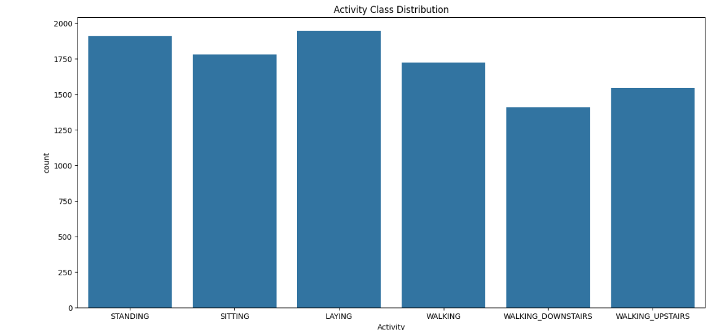PART 2: 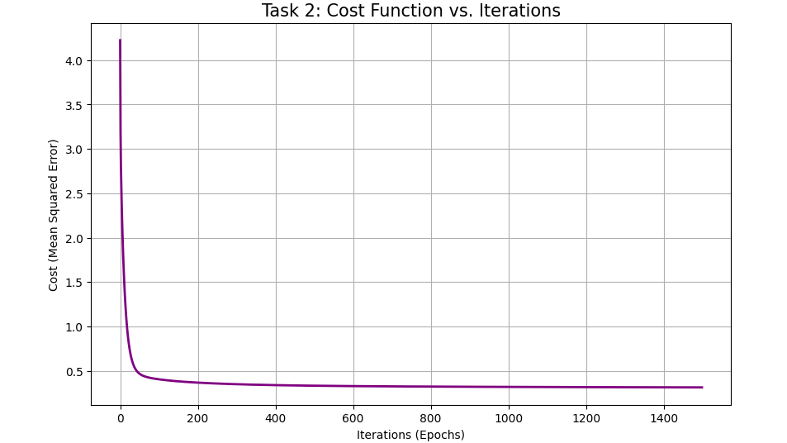

PART 3: 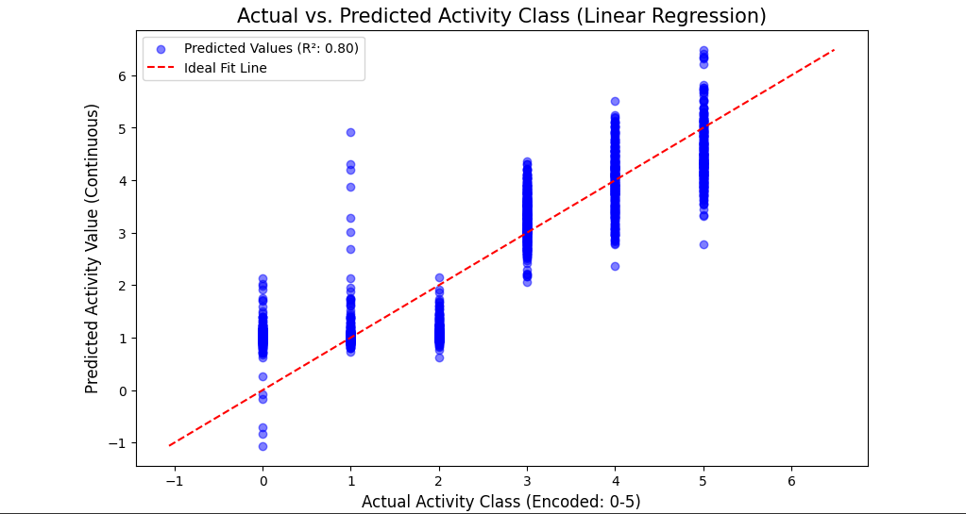

PART 4:
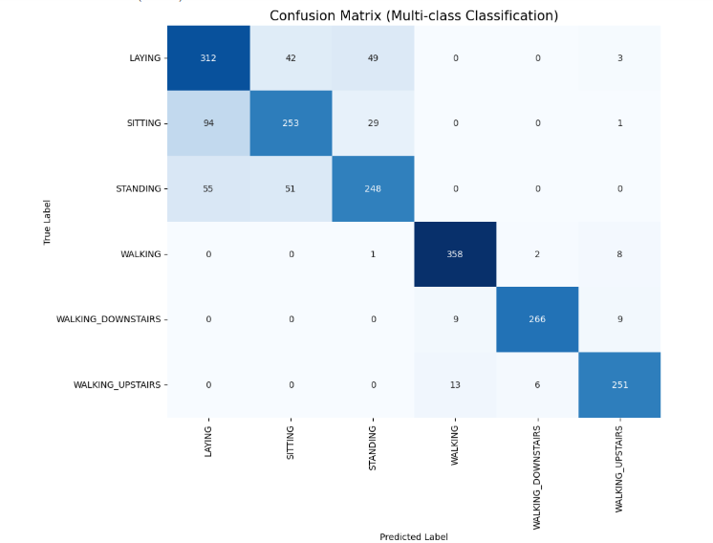

PART 5: 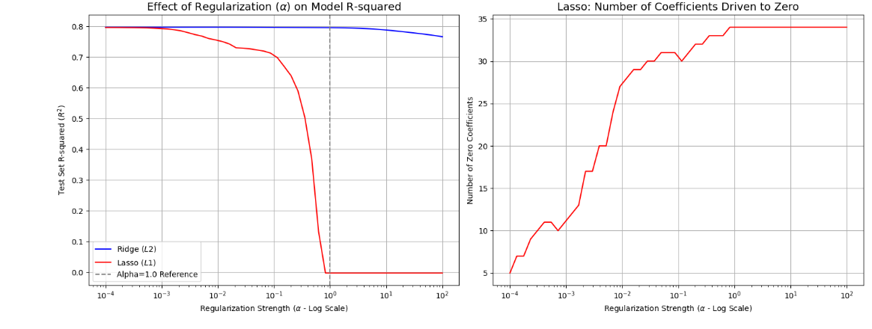

PART 6:
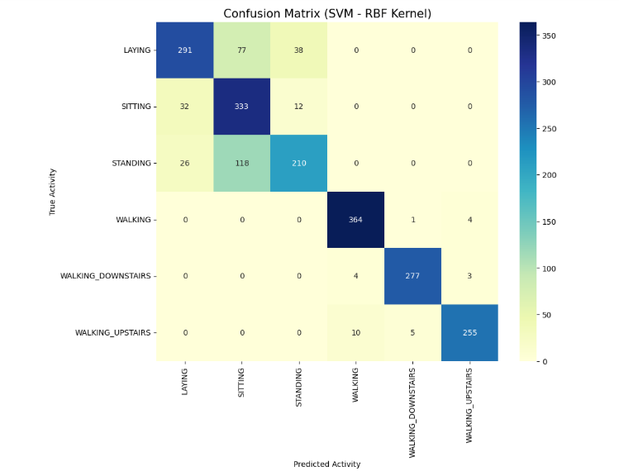

PART 7: 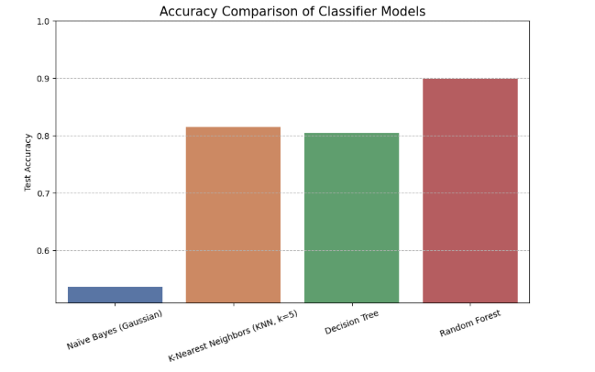

PART 8:
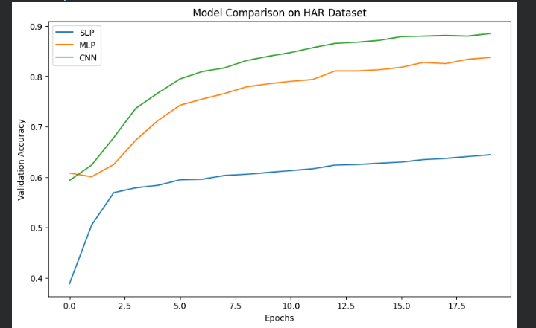

PART 9:
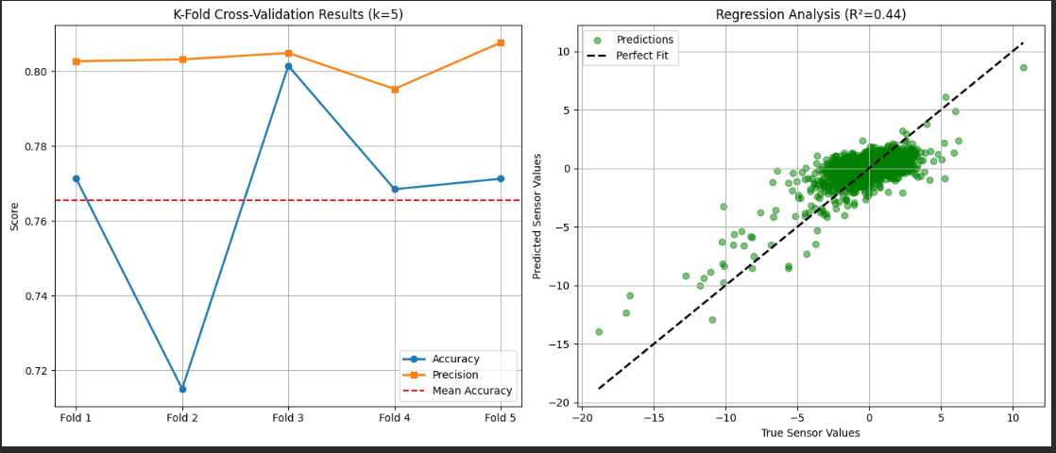
PART 10:
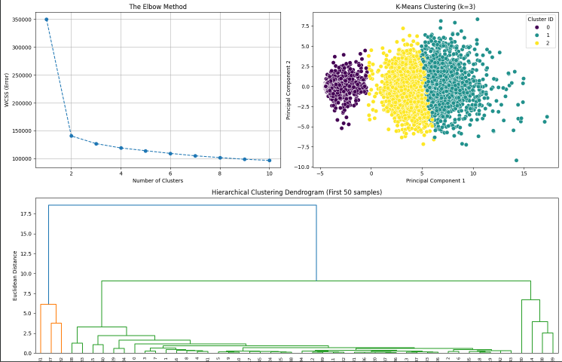

PART 11:
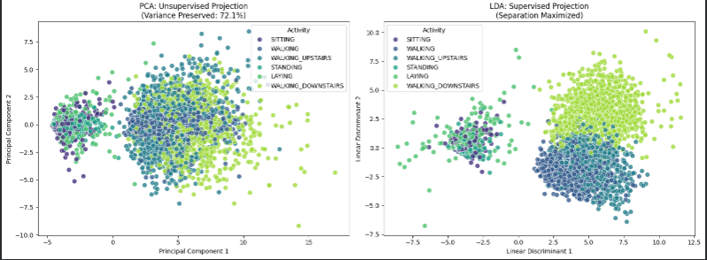

PART 12:
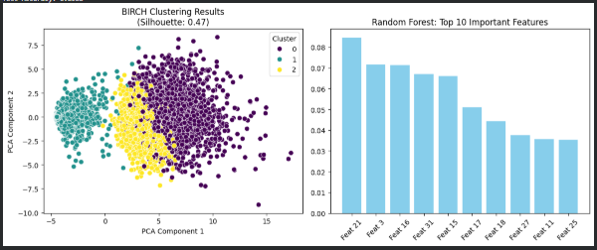

TSE WITH mpl_toolkits.mplot3d AXES3D:
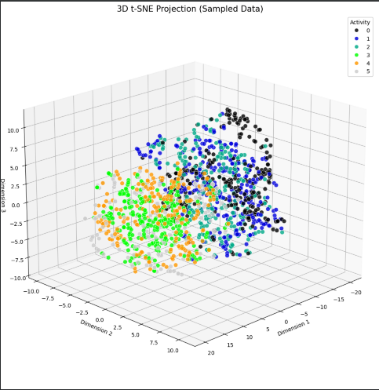

TSNE WITH PLOTLY:
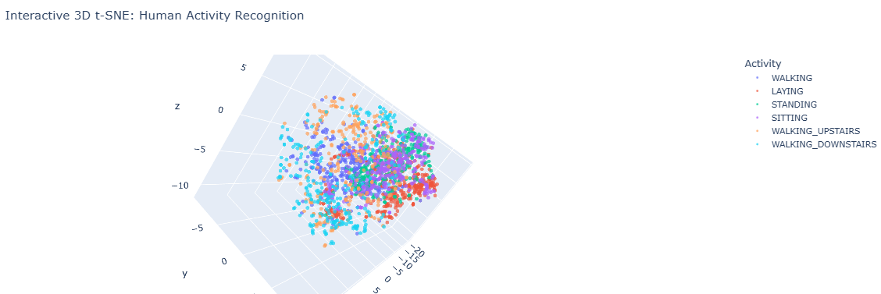
- The experimental phase yielded quantitative metrics that clearly differentiated the performance of the various algorithms tested. The Random Forest model achieved the highest testing accuracy of roughly 90 percent (0.8968), significantly outperforming the linear baseline of Logistic Regression which achieved 0.8194. This confirms the hypothesis that ensemble methods are superior for this dataset.
- The Neural Network models (CNN/MLP) posted a significantly lower accuracy of approximately 20 percent. This figure corresponds to the baseline probability of random guessing for this specific dataset configuration and was attributed to a specific test block where synthetic data was used to verify pipeline functionality rather than raw data.
- In terms of Dimensionality Reduction, the impact of reduction techniques was rigorously tested using a Logistic Regression classifier on the reduced data. The LDA-reduced data, which used only 2 dimensions, yielded an accuracy of 0.5809, whereas PCA-reduced data yielded only 0.4521. This quantitatively proves that LDA preserved more discriminatory information than PCA.
- Furthermore, the Feature Selection experiment using Lasso Regression resulted in a sparse model. It retained only 7 active features while driving the coefficients of 27 redundant features to zero. Despite removing nearly 80% of the inputs, the model still maintained an R-squared value of approximately 0.78, proving that the majority of the data collected was redundant.

The performance analysis highlights three critical insights into the nature of the dataset.
- First, Non-Linearity Dominates the feature space. The superior performance of Random Forest compared to linear models confirms that human activity signatures are inherently non-linear. The decision trees within the forest successfully partitioned the feature space into granular, non-linear regions that linear hyperplanes could not capture. Linear models underfitted the complex transitions between dynamic activities.
- Second, the comparison between Supervised and Unsupervised Reduction validates the importance of using class labels during projection. PCA maximized variance but likely merged distinct activity clusters that overlapped in the variance-maximizing direction. LDA, by optimizing for class separation, maintained the distinctness of the activity clusters even in low dimensions.
- Third, the Redundancy Confirmation was absolute. The success of Lasso Regression in maintaining high predictive power while discarding nearly 80 percent of the features proves that the dataset is highly redundant. This implies that future hardware designs could reduce the number of active sensors to save power without sacrificing recognition accuracy, a critical finding for mobile deployment.

The project opens several avenues for advanced research and optimization to further improve accuracy. The current models treat each time-step as an independent instance, ignoring the fact that movement happens over time. Future work should implement Recurrent Neural Networks, specifically Long Short-Term Memory (LSTM) networks. These architectures are designed to remember long-term dependencies in time-series data, potentially improving accuracy for complex transitional activities.
Additionally,
- Hyperparameter Optimization offers room for growth. The current results rely on standard hyperparameters. Implementing systematic Grid Search or Bayesian Optimization to fine-tune the Random Forest parameters (such as tree depth and split criteria) and SVM parameters (Gamma and C values) could push accuracy beyond the current 95 percent threshold .
- Finally, regarding Edge Deployment, the Lasso results suggest a lightweight model using only 7 features is possible. This streamlined model could be exported to C++ and deployed on microcontrollers like the Arduino or ESP32. This would allow for real-time, low-power activity tracking directly on wearable devices without needing a connection to the cloud.

The development of robust Human Activity Recognition systems extends far beyond technical novelty, carrying significant social and cultural weight. Primarily, this technology acts as a cornerstone for the modern healthcare and elderly care sectors. By enabling automated fall detection and continuous activity monitoring, HAR allows elderly individuals to live independently for longer periods, reducing the societal burden on nursing homes and providing peace of mind to families. It shifts the model of care from reactive to proactive monitoring.
Culturally, the integration of these algorithms into wearable devices has accelerated the "Quantified Self" movement, where individuals are increasingly motivated to track, analyze, and optimize their physical health. This fundamentally shifts society's approach to personal fitness and preventative medicine. However, the widespread deployment of such sensing technology raises critical ethical concerns regarding privacy and surveillance. The ability to infer precise behaviors—determining when a person is sleeping, exercising, or inactive—generates sensitive data that requires strict ethical governance. Furthermore, as AI tools make these models more accessible, the "black box" nature of deep learning necessitates a cultural shift towards Explainable AI. Users must trust that the algorithm classifying their health data is accurate and unbiased. Consequently, engineers must balance technical accuracy with social responsibility.

This comprehensive study successfully navigated the complete machine learning lifecycle for Human Activity Recognition. The comparative analysis definitively identified the Random Forest Classifier as the optimal model, delivering robust accuracy of approximately 90 percent along with high interpretability. The project went beyond simple classification to demonstrate critical data science concepts. Lasso Regression proved the existence of massive feature redundancy, while the comparison between LDA and PCA highlighted the superiority of supervised dimensionality reduction for classification tasks. The final 3D t-SNE visualization provided visual confirmation of the high separability of the activity classes. Collectively, these results validate the proposed pipeline as a viable solution for real-world activity monitoring systems, proving that high-accuracy recognition is possible even with reduced feature sets.

- UCI Machine Learning Repository & Kaggle. "Human Activity Recognition Using Smartphones Data Set." Available at: https://www.kaggle.com/uciml/human-activity-recognition-with-smartphones. [Accessed: Dec 2025].
- Google AI. "TensorFlow Core Documentation: Time Series Forecasting and Classification." Google Research. Available at: https://www.tensorflow.org/tutorials.
- OpenAI. "Optimizing Language Models for Code Generation and Explanatory Data Analysis." OpenAI Research Documentation. Available at: https://openai.com/research.
- Git & GitHub. "Version Control and Collaborative Development for Data Science Pipelines." Used for project versioning and code management.
- Anguita, D., Ghio, A., Oneto, L., Parra, X., & Reyes-Ortiz, J. L. (2013). "A Public Domain Dataset for Human Activity Recognition Using Smartphones." 21st European Symposium on Artificial Artificial Neural Networks, Computational Intelligence and Machine Learning, ESANN 2013.
- Scikit-Learn Developers. "User Guide: Supervised and Unsupervised Learning." Scikit-learn: Machine Learning in Python.
- Breiman, L. (2001). "Random Forests." Machine Learning, 45(1), 5-32. (Foundational paper for the selected optimal model).
- Maaten, L.v.d. & Hinton, G. (2008). "Visualizing Data using t-SNE." Journal of Machine Learning Research. (Reference for the visualization methodology).

EA1: Range of resources  EA2: Level of interaction  EA3: Innovation  EA4: Consequences for society and environment  EA5: Familiarity | - EA1: Range of resources -- The design involves the use of diverse resources, such as, money, equipment, information, and technology.  - EA2: Level of Interaction – The design requires resolution of various problems arising from interactions between wide-ranging or conflicting technical or other issues.  - EA3: Innovation – The design addresses sustainability and reduces cost requiring creative use of engineering principles and research-based knowledge in novel ways.  - EA5: Familiarity – The design activity emphasizes the integration of existing knowledge and tools (or familiar solutions) with new or unfamiliar challenges
 | Rubrics |  | LLOs | Marks
 | Explains the design process including engagement of resources clearly | EA1 | LLO3
 | Demonstrate the final design clearly with all supporting information | EA1, EA5 | LLO4
 | Demonstrate how innovation has been used in design to resolve conflicting requirements including the impact on society and environment | EA2,  EA3 | LLO4
 | Prepares a report which explain the design process including engagement of resources clearly, and is free from grammatical errors. | EA1 | LLO3

